Ethan Hua
Rodrigo Becerril Ferreyra
California State University, Long Beach
Professor Minhthong Nguyen
Blackjack Final Project
10 December 2021

Introduction
The purpose of this project is to test our skills and knowledge acquired this semester. Specifically, our task is to implement the game of Blackjack (also known as 21) in C++. This project tests our knowledge of object-oriented programming (classes, objects, etc.), data structures, and file management. Additionally, this project tests our teamwork and communication skills.
The following is a brief summary of the project requirements: the game is to be implemented on the command line, to avoid any GUI-related issues. The game will follow a standard game of Blackjack (rules available here) played with one deck. The game is played by the player against the dealer. Along with the standard rules, the player is allowed to split his or her hand if the first cards he or she receives are the same value; this split is only allowed once, meaning that the player can have a maximum of two hands. The total amount of money the player has won or lost is stored in an “account” file, which also stores a user ID and the number of games won.

Program Analysis and Design
There are three classes required by the project specifications:
- an Account class.
- a Card class.
- a Player class.
The Account class is in charge of file-handling functions. It makes sure to save the results of every game into a file so it can be retrieved later. The Card class (named CardList) is implemented as a linked list; a list of Cards can represent a player’s hand or a deck of cards. The Player class implements functions that players perform, such as the action the user will take (hit, stand, split). All these classes work together to create a game.
The game itself follows a standard Blackjack format: first, a deck is created. Then, cards are dealt to both the player and the dealer. The dealer then reveals one of his cards, and the player is given a choice to perform an action: hit or stand (additionally split if the cards are the two cards dealt have the same value). If the player chooses to hit, he or she is dealt another card and asked to perform an action. This continues until the player chooses to stand or the value of the player’s hand reaches or exceeds 21. Meanwhile, the dealer automatically draws cards until the value of his hand reaches or exceeds 17. After both players have played, the hands are compared, and the game is finished.

Screenshots
Game 1 (KNOWN ACCOUNT, SPLIT, HIT ON BOTH HANDS, LOST 1, WON 2)
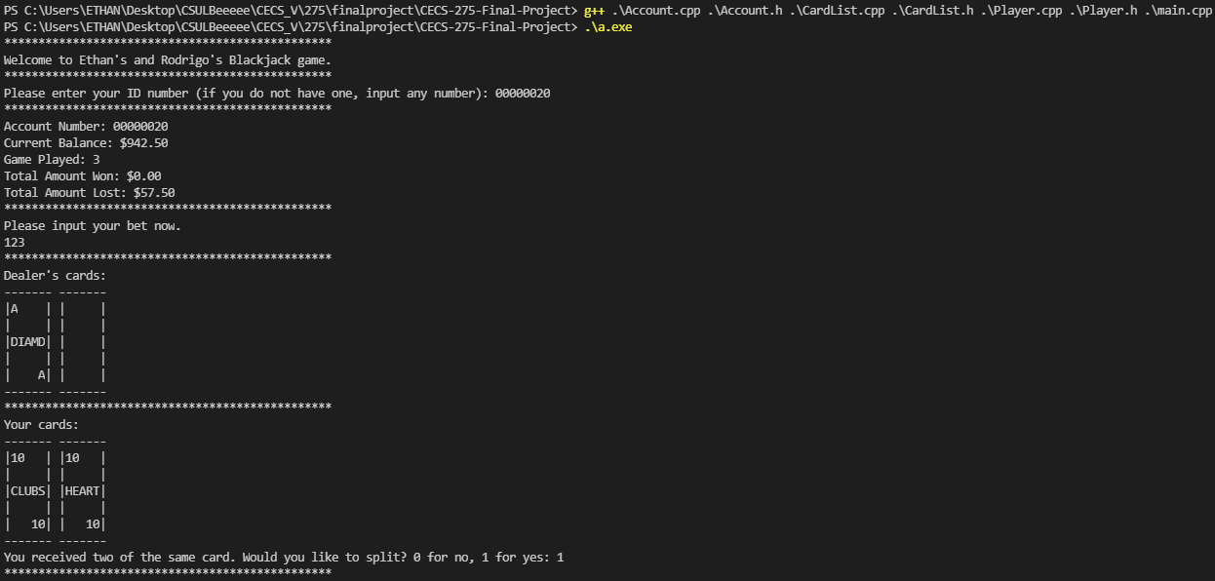

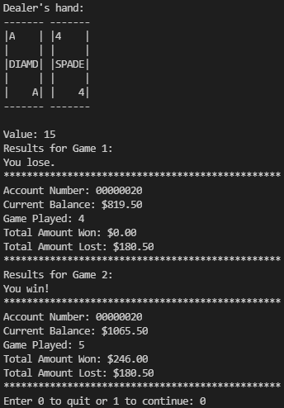
Game 2 (GENERATED 8-DIGIT ACCOUNT FROM 7-DIGIT INPUT, 1 HAND, STAND, WON)

Game 3 (CONTINUOUS PLAY)
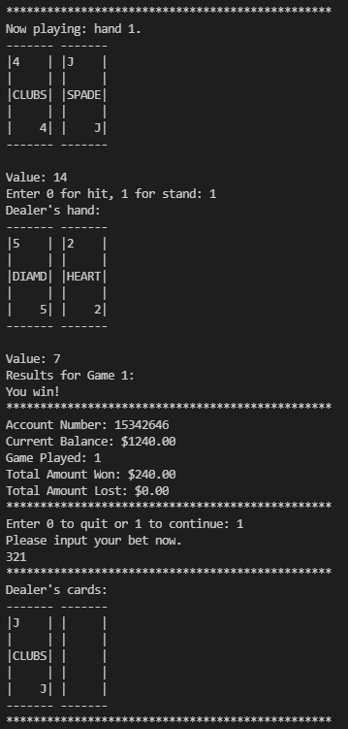
Account with many games played on it
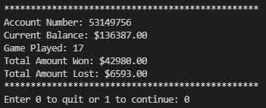
Files updating
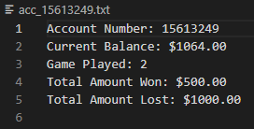
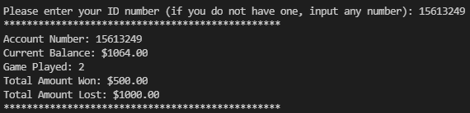
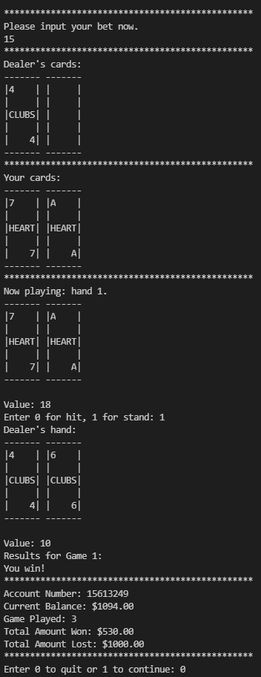
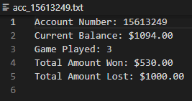
9-digit ID error handling (also, a tie game)
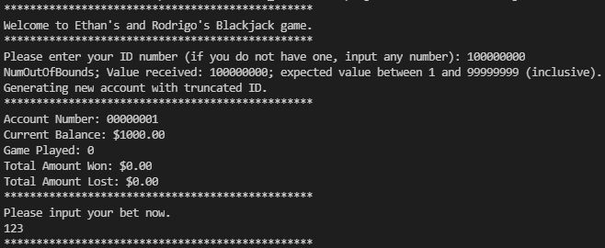
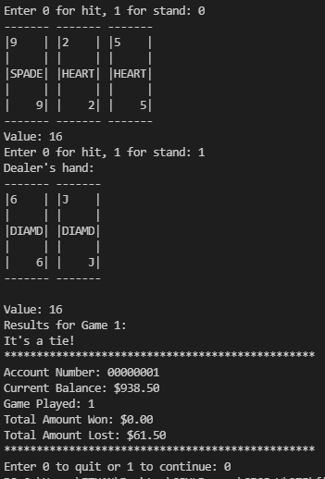
Account with many games on it
Choosing not to split

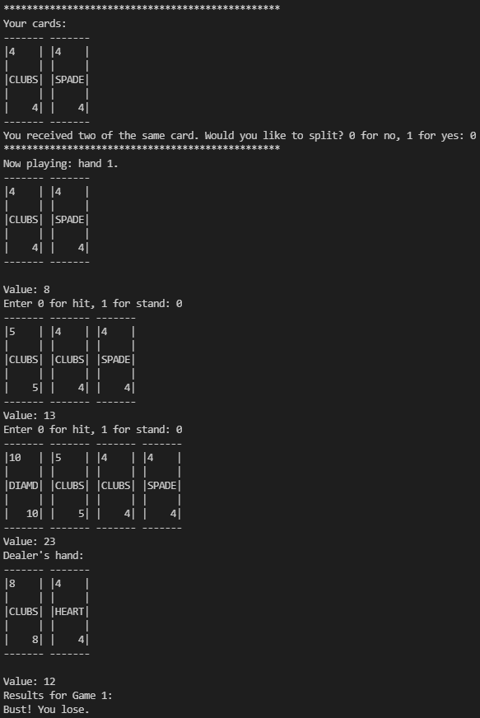
Diagram
